Information architecture

# News Article

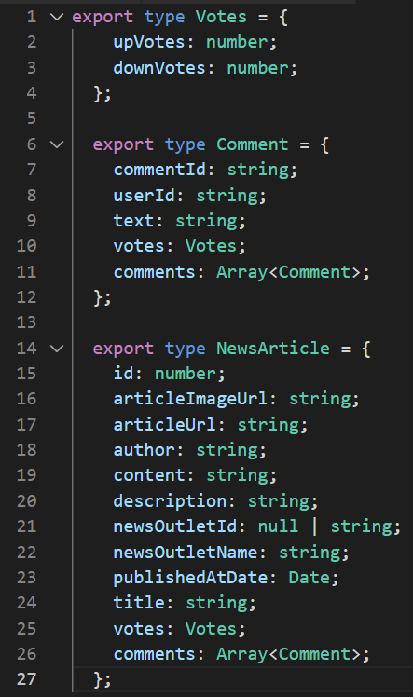

News Articles are defined by this type, and will be fetched in the Frontend like this.  
Every Article also contains a Comment array, which can also contain another Comments array. Thus the child comments can be easily determined by the structure of the data itself.   
Up-Votes and Down-Votes are simply stored in every Article and Comment.

# User

# 

Our initial User-Data will only contain the necessary:

* **Id** for comments
* **AuthenticationToken** to authorize the user activity
* **Name** as the username
* **Mail** for password recovery and login purposes

A **password** Attribute will be stored in the database for login purposes as well, which will not be retrieved in the frontend.